******,

Hi. Thank you very much for coming to Land Lubbers holiday club. We hope you enjoyed yourself and had loads of fun…like we did! Thank you to all of you who came to our service on Sunday, it was great to see you there. Church meets every Sunday at 10.30 we would love to see you and your family there. During these services we have Sunday School, which is also loads of fun!
During term time at Slough Baptist Church there is a group called 'Tuesday Break' which meets from 10 -11.15am. Each week there is a different speaker and if you have a baby or child aged under 5- there is a crèche. During the summer they meet at Salt Hill Park in the play area- feel free to come along, the dates are 9th and 30th August at 11.30.
Below is a picture of the whole Land Lubbers team and also a photo of the group you were in, the ****. The picture was taken on Friday, so if you weren't there we are really sorry.
Start looking forward to next years holiday club, because next year is going to be even bigger and better!!! If you have any comments on the holiday club please e-mail Jem at jem@slough.baptistch.net

Thanks. Enjoy the summer!
The Holiday Club Team
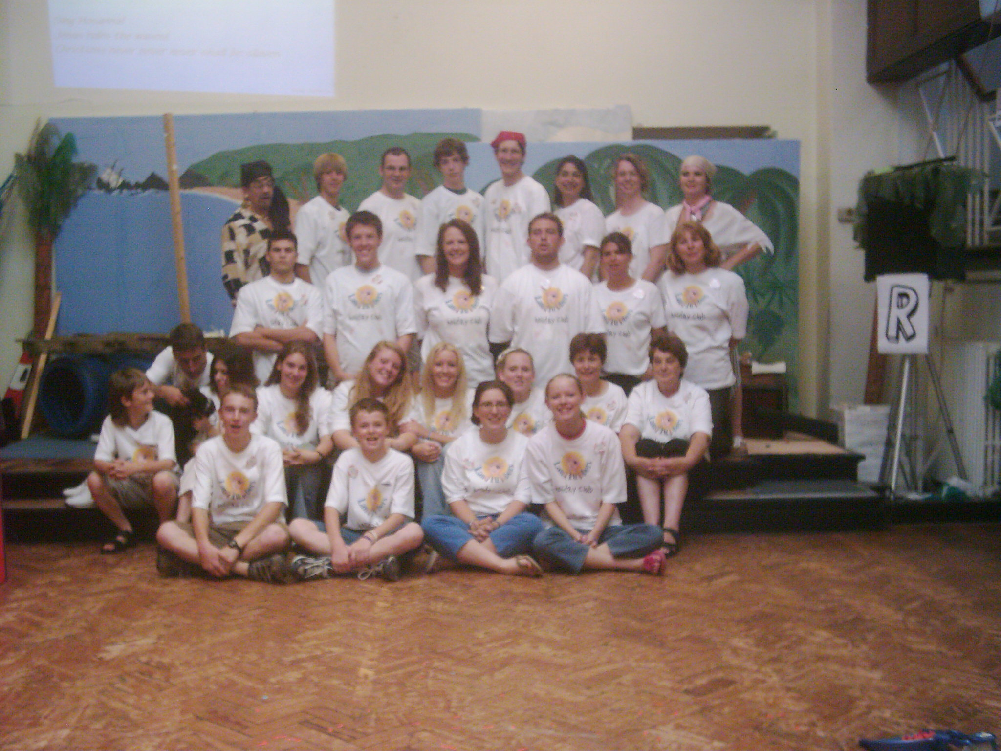
< This is our team.
27 of us!

In this spot you could put a photo of the relevant group

