Our Craft ideas

Day | Ice Breaker | Main craft
Monday | Individual map | Small chests
Tuesday | Large map | 3D parrot
Wednesday | Large map | Light houses
Thursday | Prayer in a bottle | Decorate chests AND tea bag paper
Friday | Flags | Memory verse onto tea bagged sheet

Day 1
Ice breaker
Each child made an individual map of an island. The younger ones coloured, cut out and stuck on pictures to the island. The older group drew on their own features. (copy is on CD)

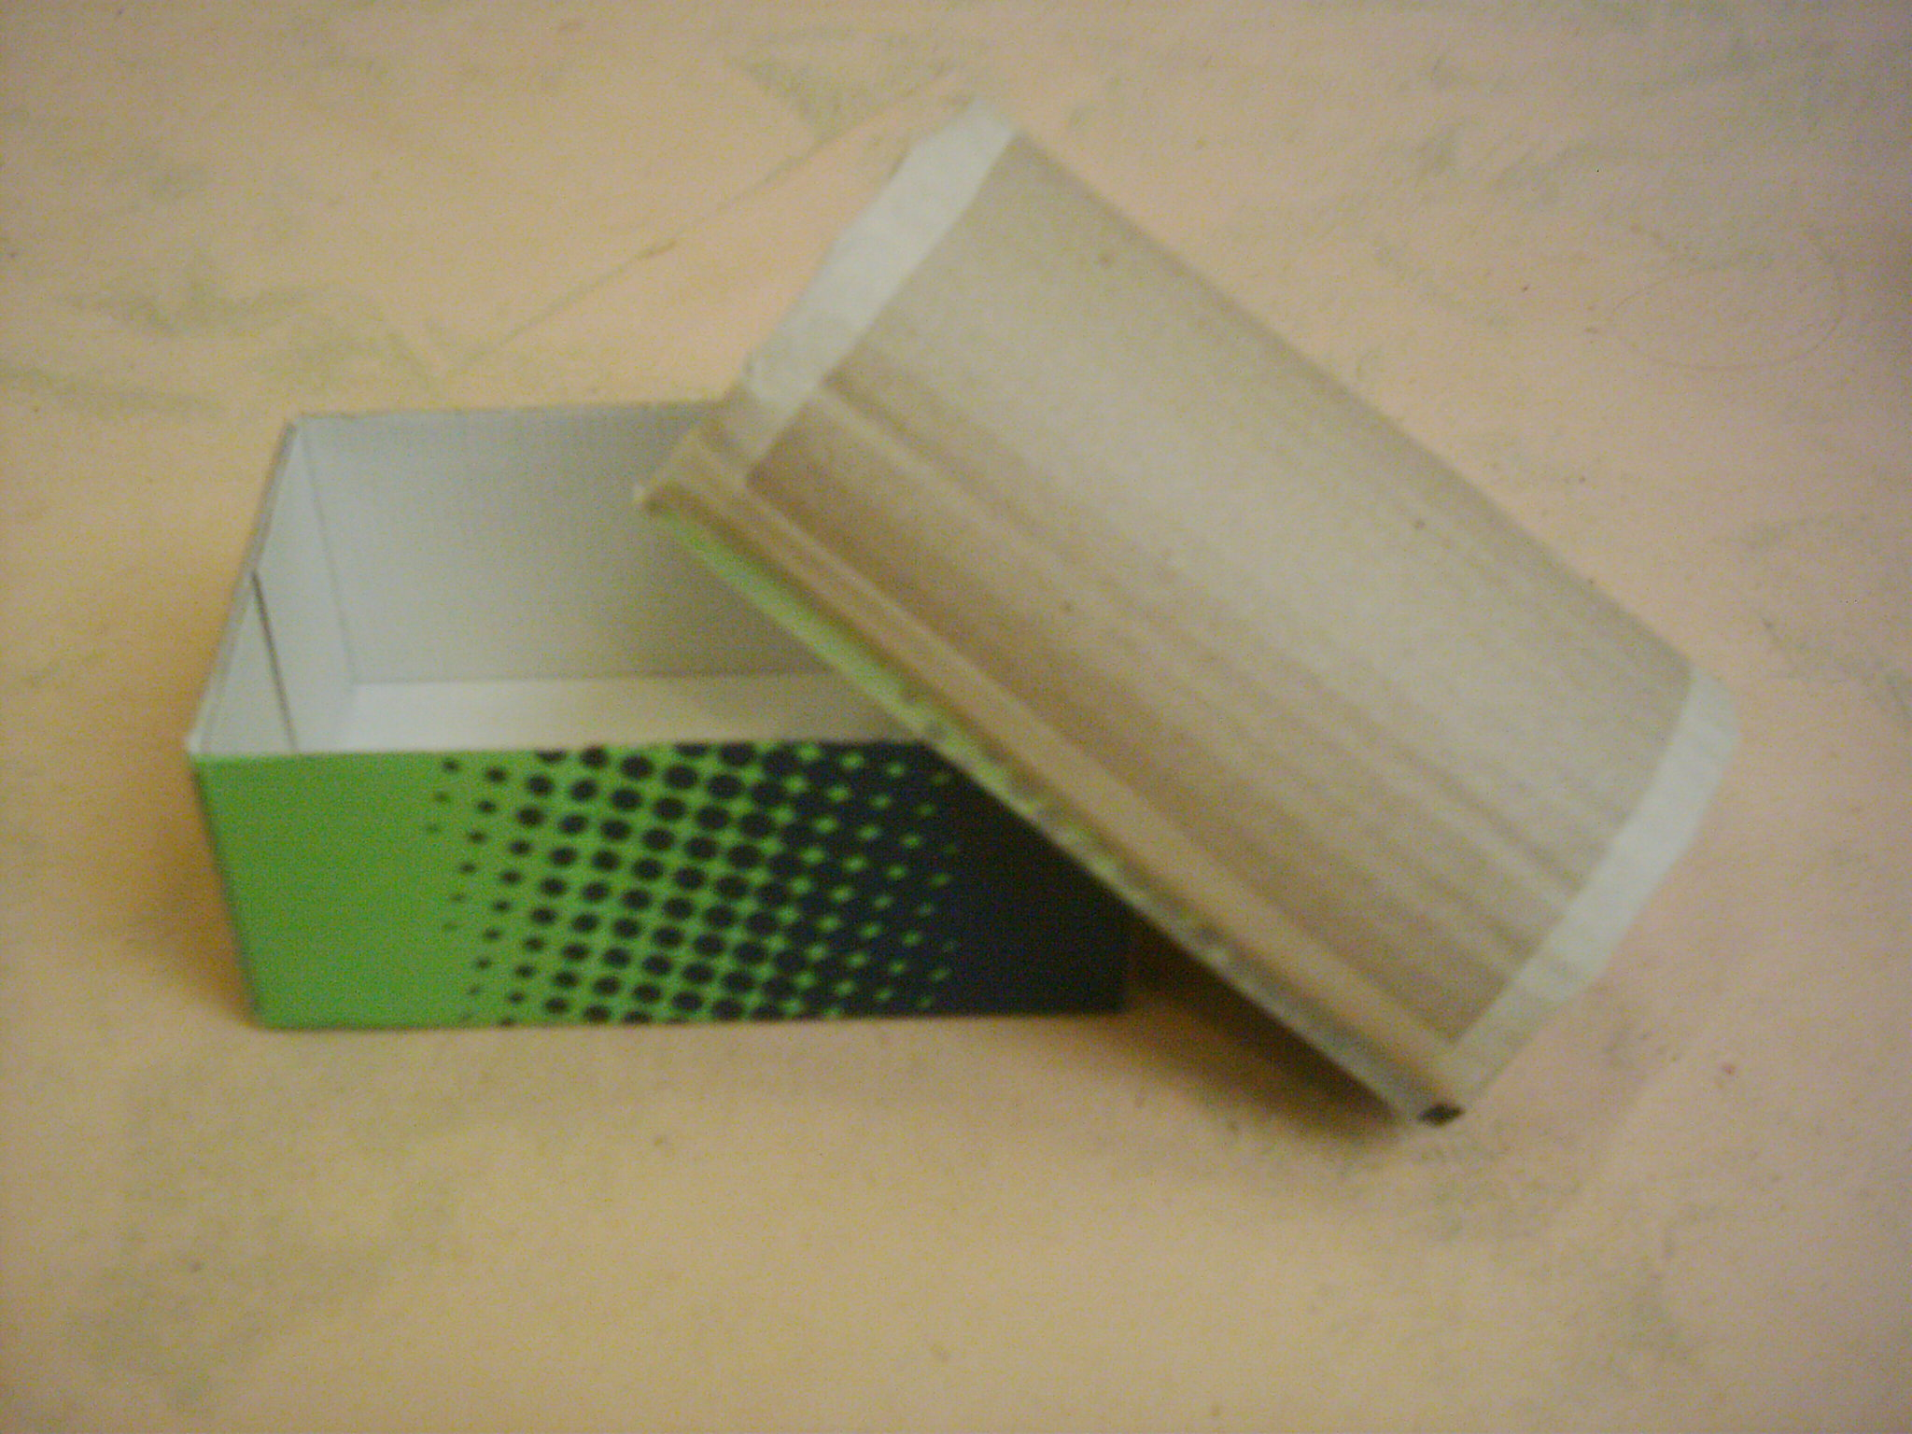
Main craft
We could not afford to buy small chests for each child so we made our own. 'Mothercare' saved us the small sized shoeboxes and we converted the lids into a rounded shape lids- like a chest. We used masking tape so that it could be painted over.

Day 2
Ice Breaker
We put large pieces of paper on the wall, drew an island shape and the children used collage to make it into an island.

Main craft
3D Parrots using pre-printed sheets were made and hung around the hall. Instructions
- Children / helpers cut out both sides of parrot, beaks and wings (as PDF files)
- Stick the wings and beaks onto the parrots
- Parrots are stapled back to back, but leave a small gap
- Insert a few tissues into gap to make the parrot 3D
- Close gap
- Hang on piece of elastic
Relevant files are located in the 'Craft' > 'Parrot' folder
E-mail benrolfe@tesco.net if you want a copy.

Day 3
Ice Breaker
Continue with island collage

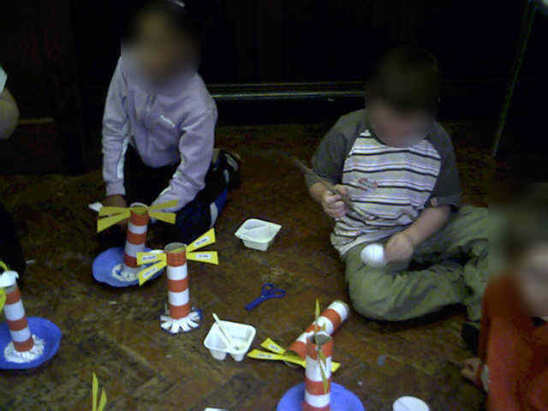
Main craft
We made lighthouses (different from the book). We used paper plates (already painted blue) added scrunched grey paper for rocks and made a lighthouse out of kitchen roll tubes. The tubes had been covered in white paper and red strips of paper were stuck on. Four 'light beams' were slotted onto the top of the tubes and the children stuck on the pre-printed words "I am / the light / of the / world". A small cone was added at the top of the lighthouse.

Day 4
Ice Breaker
The children wrote prayers, which were prayed out loud. These were put in fruit shoot bottles- 'message in a bottle'

Main Craft
2 Activities:
- Decorate chests with gold sprayed pasta, buttons etc
- Dab wet tea bags on a sheet of A4 paper to stain it (for use on Day 5)

Day 5
Ice Breaker
- Continue with collage work
- Make flags from paper and garden sticks

Main Craft
Older children write out the day's memory verse on stained tea-bagged sheets (from yesterday). Roll into a scroll and put into chests. Younger ones had the verse printed.

